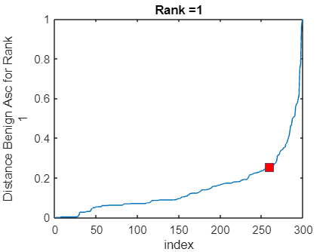

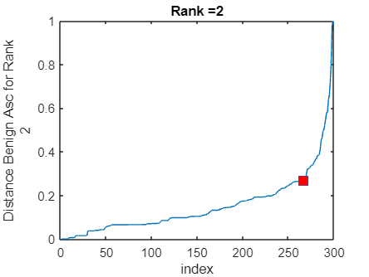

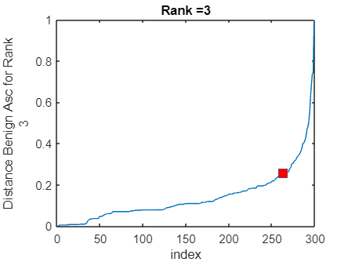

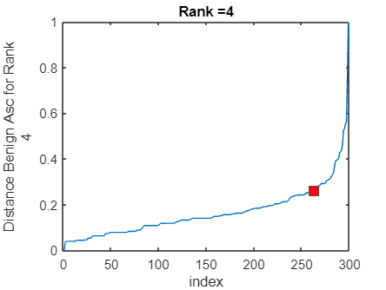

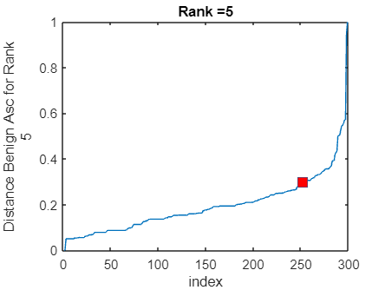

optrank_b = 2

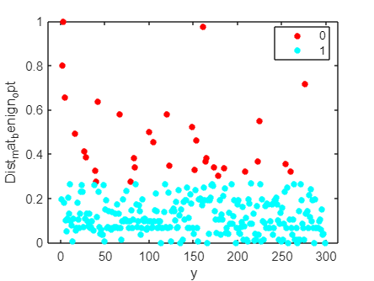

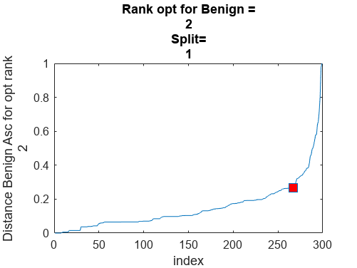

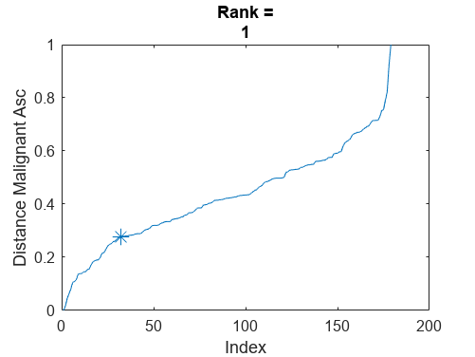

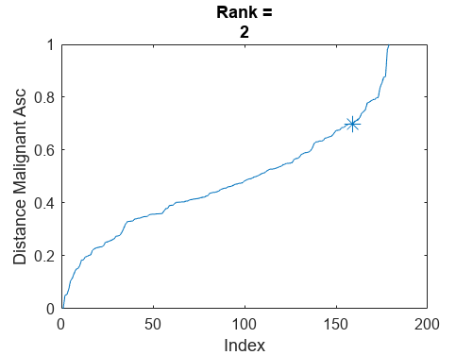

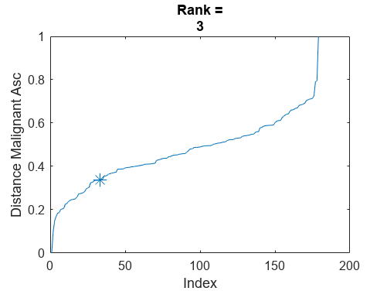

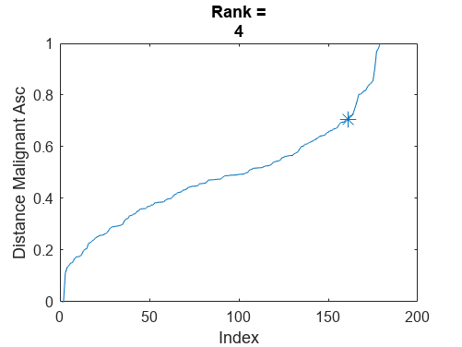

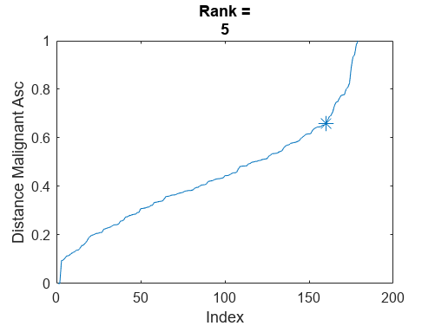

optrank_m = 5

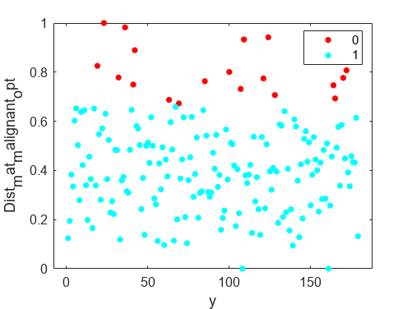

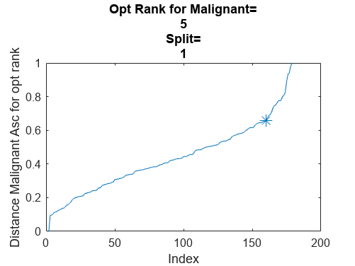

Warning: Directory already exists.

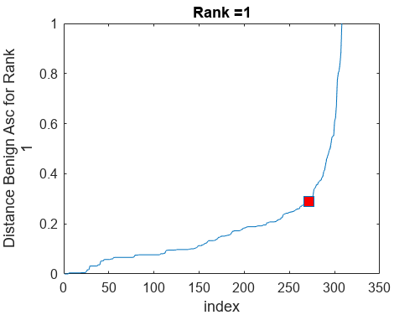

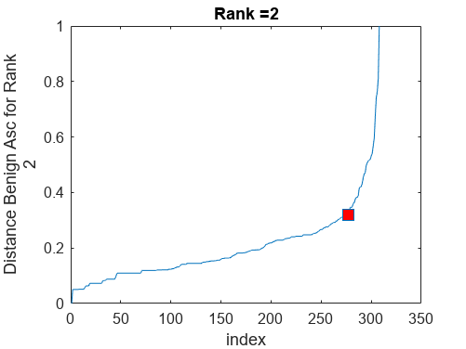

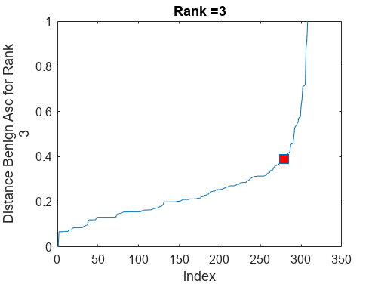

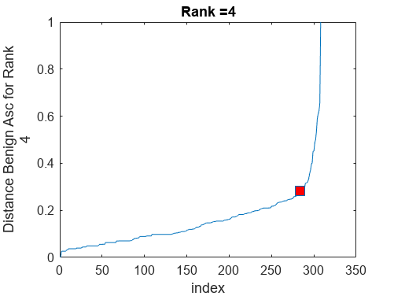

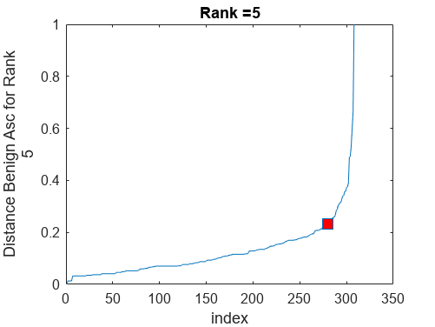

error_benign = 1×5

-0.8691 -0.8184 -0.9338 -1.1014 -0.8508

optrank_b = 4

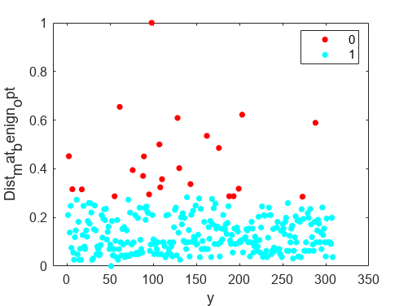

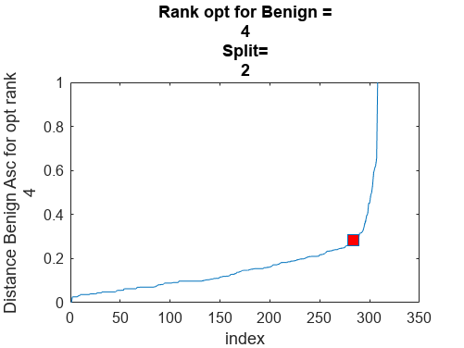

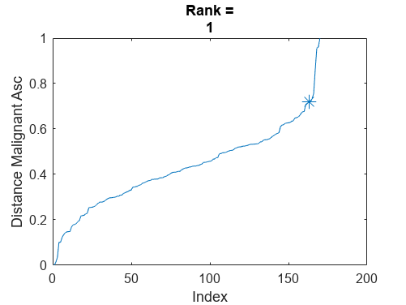

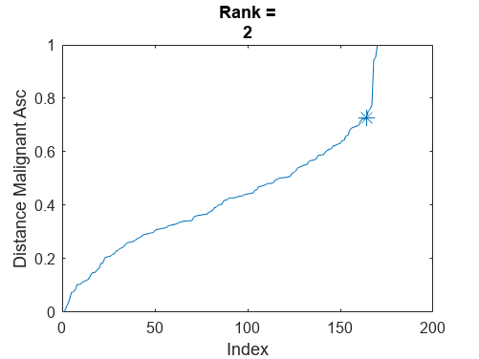

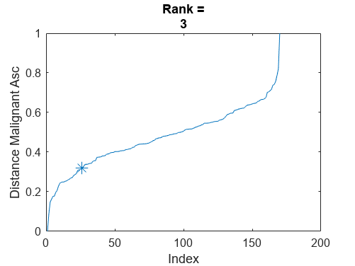

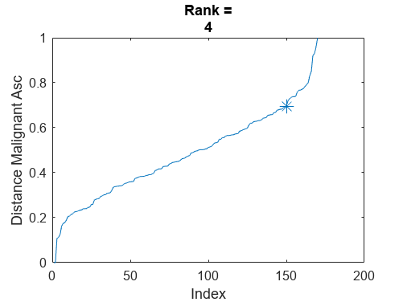

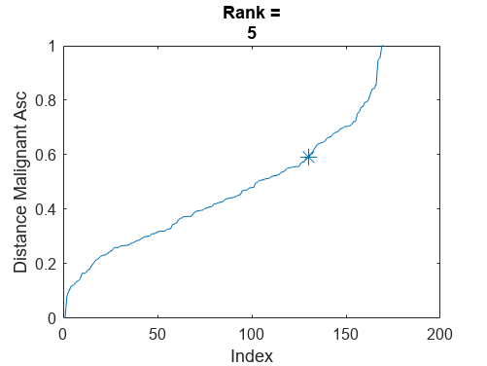

error_malignant = 1×5

-2.5016 -2.6763 0.3428 -0.5118 -0.2733

optrank_m = 2

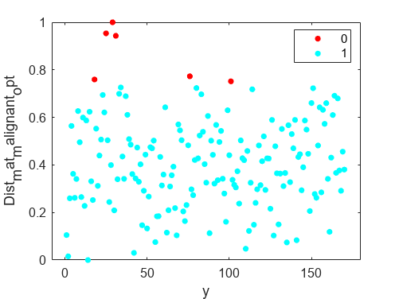

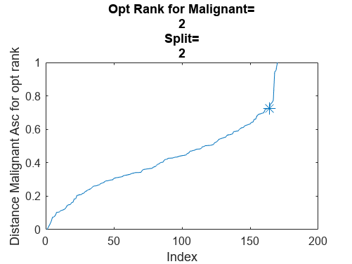

Warning: Directory already exists.

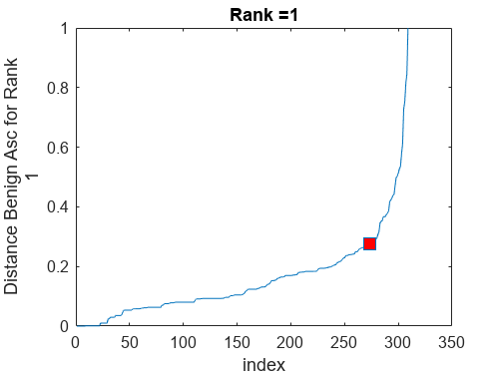

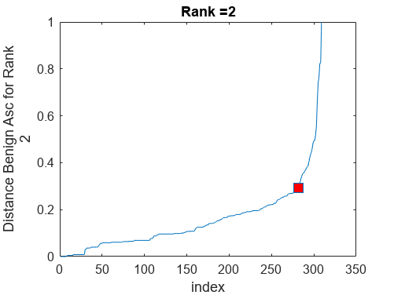

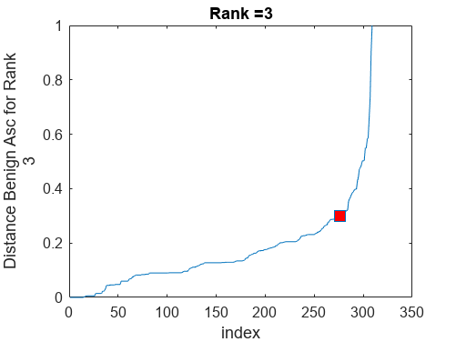

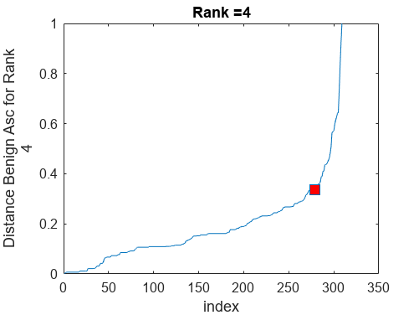

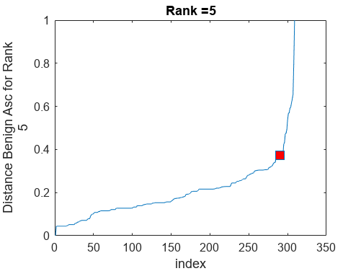

error_benign = 1×5

-0.8015 -1.1080 -0.7863 -0.9316 -1.3589

optrank_b = 5

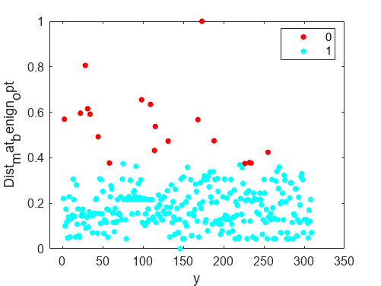

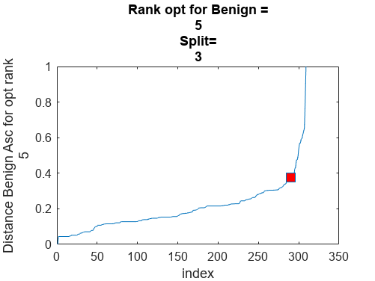

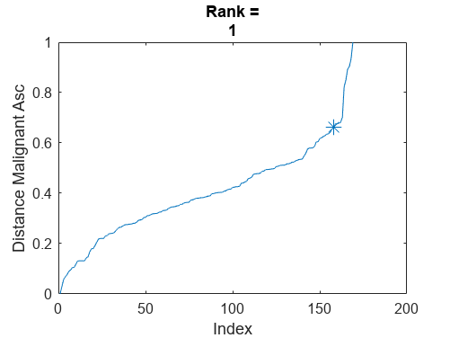

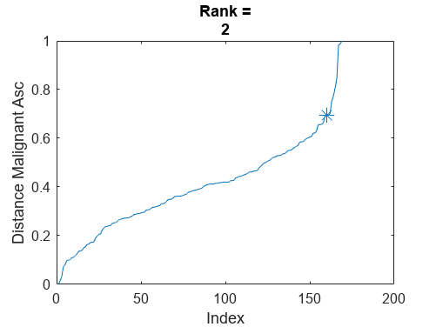

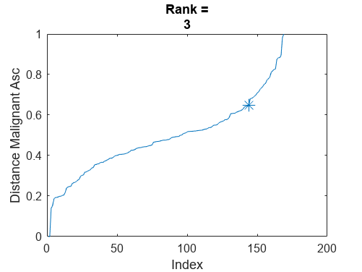

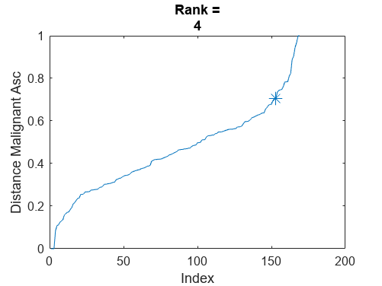

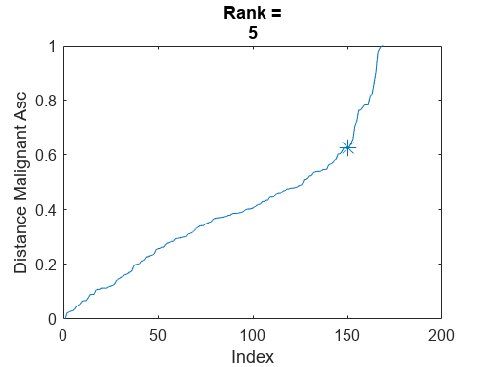

error_malignant = 1×5

-1.6898 -2.0678 -0.4965 -0.8736 -0.9420

optrank_m = 2

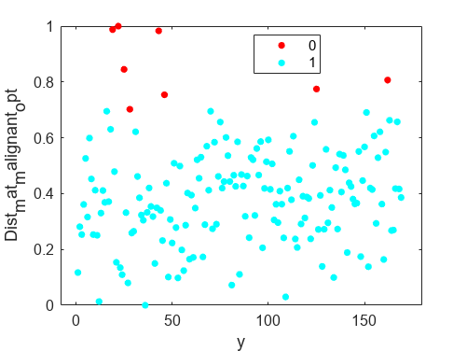

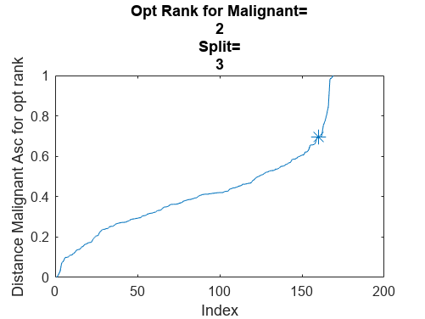

Warning: Directory already exists.

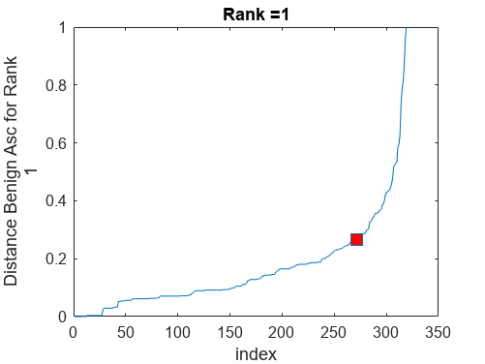

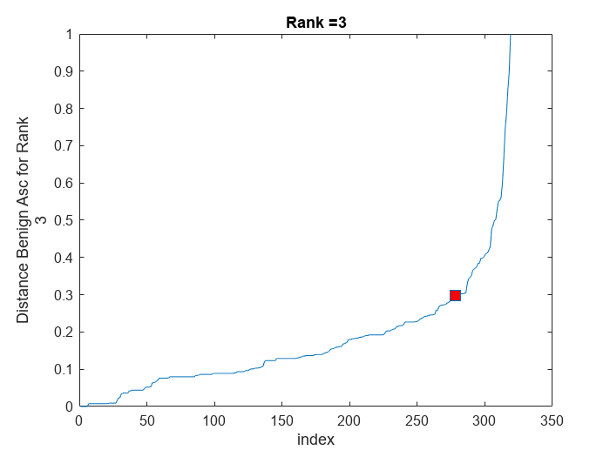

error_benign = 1×5

-0.6177 -0.7997 -0.6714 -0.7369 -0.8861

optrank_b = 5

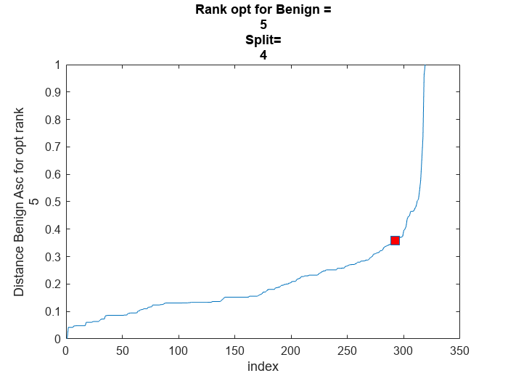

error_malignant = 1×5

-0.4647 -0.4462 -0.5908 -0.7879 -0.8167

optrank_m = 5

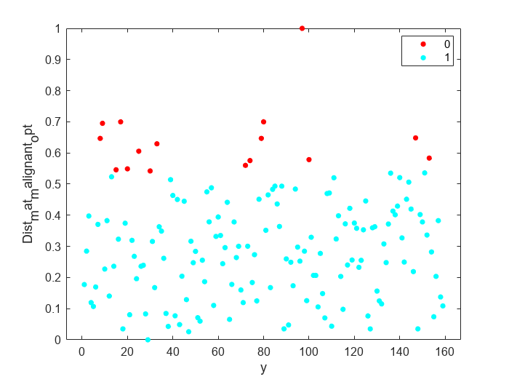

Warning: Directory already exists.

error_benign = 1×5

-0.7041 -1.0016 -0.7488 -0.9164 -1.3757

optrank_b = 5

error_malignant = 1×5

-1.1781 -0.2188 -0.5121 -1.2623 -0.5693

optrank_m = 4

Warning: Directory already exists.

error_benign = 1×5

-0.5024 -0.5254 -0.4960 -0.6217 -0.4452

optrank_b = 4

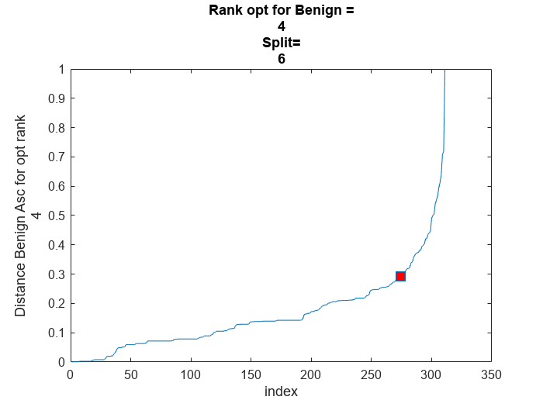

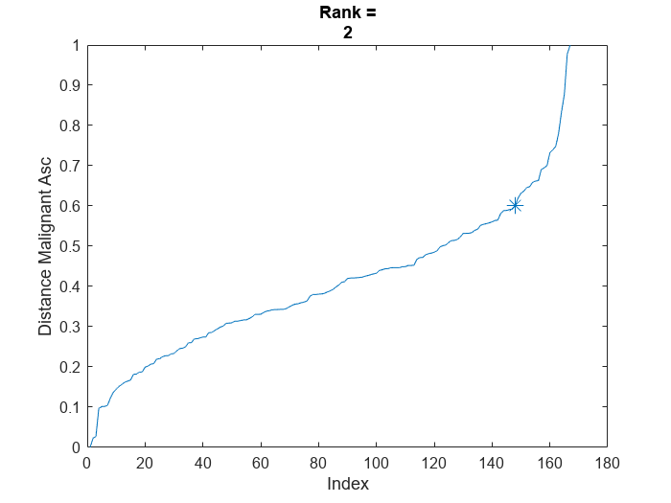

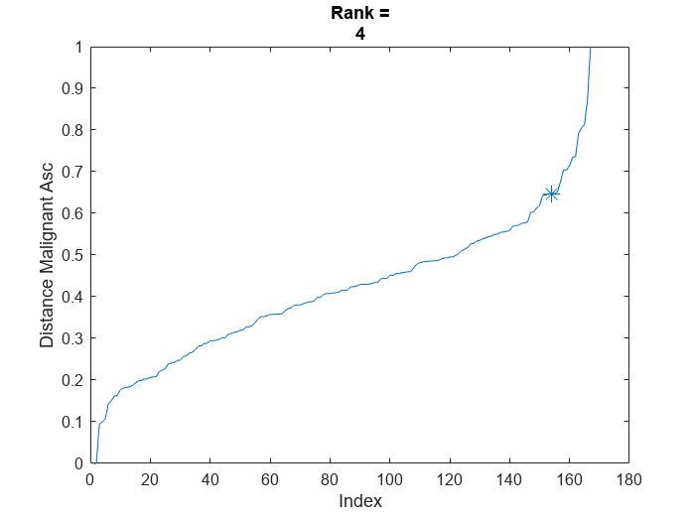

error_malignant = 1×5

-0.9421 -0.8255 -0.4954 -1.0810 -0.4047

optrank_m = 4

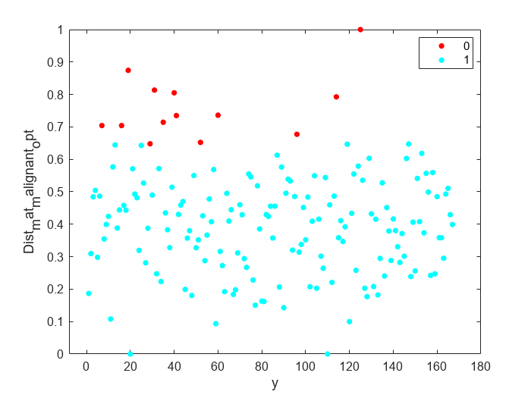

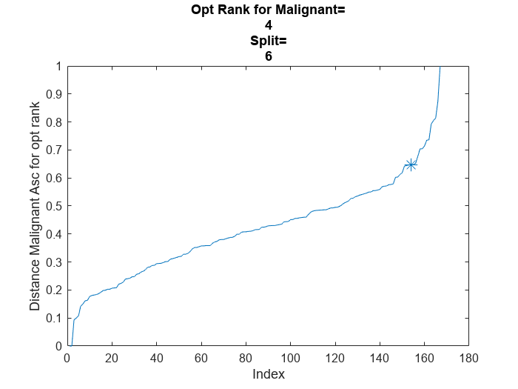

Warning: Directory already exists.

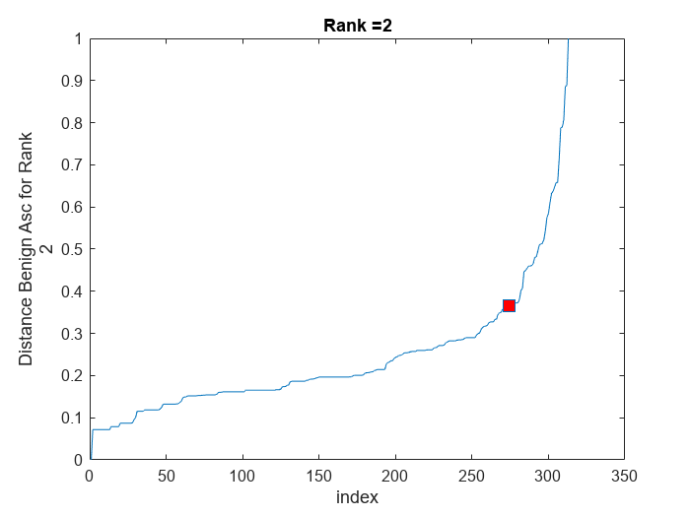

error_benign = 1×5

-0.7341 -0.7147 -0.7711 -0.7576 -1.2349

optrank_b = 5

error_malignant = 1×5

-1.1747 -1.8439 -1.3294 -0.3669 -0.4230

optrank_m = 2

Warning: Directory already exists.

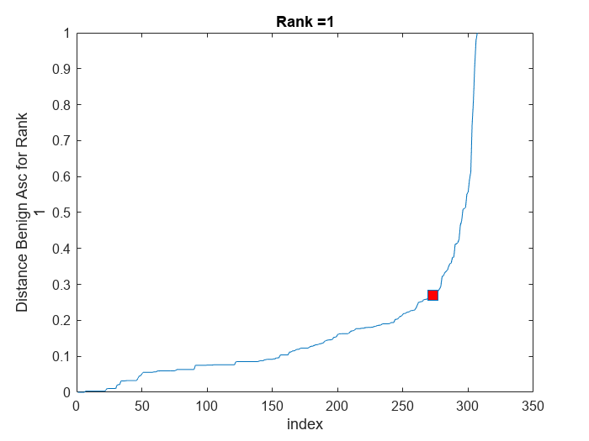

error_benign = 1×5

-0.9642 -0.9608 -1.2463 -1.3192 -2.7870

optrank_b = 5

error_malignant = 1×5

-2.0331 -0.9618 -0.3347 -0.6006 -0.7952

optrank_m = 1

Warning: Directory already exists.

error_benign = 1×5

-0.9112 -1.1245 -1.0738 -1.5731 -2.1919

optrank_b = 5

error_malignant = 1×5

-2.9513 -0.7297 -1.4276 -1.0236 -2.0236

optrank_m = 1

Warning: Directory already exists.

error_benign = 1×5

-1.0692 -1.3942 -1.2772 -0.8619 -0.6981

optrank_b = 2

error_malignant = 1×5

-1.5338 -1.9106 -0.1795 -0.8686 -0.5039

optrank_m = 2

